Supporting information

Title: Community-wide changes in inter-taxonomic temporal co-occurrence resulting from phenological shifts

Running head: Phenological shifts change community co-occurrence

Authors: Fangyuan Hua^{1,2*†}, Junhua Hu^{3†}, Yang Liu^{1*†}, Xingli Giam⁴, Tien Ming Lee², Hao Luo^{5,6}, Jia Wu⁷, Qiaoyi Liang¹, Jian Zhao¹, Xiaoyan Long¹, Hong Pang¹, Biao Wang¹, Wei Liang⁸, Zhengwang Zhang⁹, Xuejie Gao⁷, Jiang Zhu⁵
Affiliations:
¹State Key Laboratory of Biocontrol, College of Ecology and Evolution, School of Life Sciences, Sun Yat-sen University, Guangzhou, Guangdong 510275, China
²Program in Science, Technology, and Environmental Policy, Woodrow Wilson School of Public and International Affairs, Princeton University, Princeton, NJ 08544, U.S.A.
³Chengdu Institute of Biology, Chinese Academy of Sciences, Chengdu, Sichuan 610041, China
⁴School of Aquatic and Fishery Sciences, University of Washington, Seattle, WA 98105, U.S.A..
⁵Institute of Atmospheric Physics, Chinese Academy of Sciences, Beijing 10029, China
⁶University of Chinese Academy of Sciences, Beijing, 100049, China
⁷Laboratory of Climate Studies, China Meteorological Administration, Beijing 100081, China
⁸Ministry of Education Key Laboratory for Tropical Animal and Plant Ecology, College of Life Sciences, Hainan Normal University, Haikou , Hainan 571158, China
⁹Key Laboratory for Biodiversity Science and Ecological Engineering, College of Life Sciences, Beijing Normal University, Beijing 100875,China
*Correspondence to: Fangyuan Hua: +1-352-281-9763, fhua@princeton.edu
Yang Liu: +86-20-84114063, liuy353@mail.sysu.edu.cn
†These authors contributed equally to the study.
Key words: climate change, phenological shift, temporal occurrence window, interspecific temporal overlap, community assembly, China
Type of paper: Primary research article

This file includes:
SI 1: Simulation of interspecific temporal overlap change as a result of phenological shifts
SI 2: Description of data collection protocol and summary of original and trimmed phenological data set
SI 3: Supplementary methods
SI 4: Supplementary results

SI 1. Conceptual simulation of temporal overlap change between two hypothetical species as a result of shifts in their temporal occurrence windows
Original patterns of temporal overlap: The original patterns of temporal occurrence windows of two hypothetical species (denoted as species a and b corresponded to those depicted in Fig. 1a, and can be expressed against a hypothetical time axis as follows. Species a’s temporal occurrence window started at time unit 2, and had a span of three time units; species b’s temporal occurrence windows started at time unit 0, and had a span of four time units. The original span of temporal overlap between species a and b was thus two time units.
Scenarios of shifts in species’ temporal occurrence windows: For scenario simulations of species’ temporal overlap change, our goal was to explore the probability density of different temporal overlap spans under three categories of shift scenarios that assumed unchanged (category A), prolonged (category B) or shortened (category C) spans of species’ temporal occurrence windows. For categories B and C, three specific scenarios were involved for each category where changes in the span of species’ temporal occurrence windows applied to species a only, species b only, or both species; our simulation thus involved seven specific scenarios. All changes in the span of species’ temporal occurrence windows were fixed at a value of one time unit when they occurred, with the recognition that this was a highly simplified representation of the possible changes in the span of species’ temporal occurrence windows. For all scenarios, the shift directions and extents of temporal occurrence windows were assumed to follow a standard normal distribution (mean of zero and variance of one); this was achieved by randomly drawing a value from the standard normal distribution to define the shift values of the start point of both species’ temporal occurrence windows for each simulation run. Such a simulation approach rendered larger shifts to be less likely than smaller shifts, and advances to be equally likely as delays. We believe that it sufficed for the purpose of illustrating the range of possible outcomes in response to climate change. In sum, our simulation was hinged upon the normally distributed random shift of species’ temporal occurrence windows of known spans, with 10,000 runs for each scenario. We plotted the kernel density of temporal overlap between species a and b after simulated shifts of temporal occurrence windows, using R.3.0.2 (R Core Team 2013).
References:
R Core Team (2013) R: a language and environment for statistical computing. R Foundation for Statistical Computing. Vienna, Austria. URL: http://www.R-project.org.

SI 2. Description of data collection protocol and summary of original and trimmed phenological data set
China Meteorological Administration established a nationwide phenological monitoring network in 1980. This network involved around four hundred municipality-/county-level meteorological observatories that were already under the National Agrometeorological Monitoring Network; phenology data collection was to be undertaken by observatory staff members following guidelines laid out in China Meteorological Administration (1993). Animal taxa whose phenophases were the subject of phenological monitoring included ~50 wide-ranging, common species/species groups of insects, amphibians, reptiles and birds (Table S1); brief descriptions of their morphology and behavior were required as part of data collection to assist with taxonomic identification. For each species/species group, standard data collection involved recording the date, at each observatory, of it first and last sighting/calling dates during a given year, into the format used in collecting annual agrometeorological records (No. QX/T 21-2004).
References:
China Meteorological Administration (1993) Agricultural meteorological observation standard (Vol I). Beijing: China Meteorological Press, pp. 133-200.

Table S1. List of taxa and their respective number of phenological records in the original data set transcribed from National Meteorological Information Center of China.
Higher grouping | Taxon | Taxon name in Mandarin | Taxon name  in Pinyin | Operational taxon | Number of sites | Number of time series records for
 |  |  |  |  |  | First sighting | Last sighting
Insect | Cricket | 蟋蟀 | Xishuai | Cricket | 70 | 70 | 70
 | Cicada | 蝉鸣 | Chanming | Cicada | 1 | 1 | 1
 | Cicada | 蝉 | Chan | Cicada | 13 | 13 | 13
 | Cicada | 知了 | Zhiliao | Cicada | 5 | 5 | 5
 | Cicada | 伏蝉 | Fuchan | Cicada | 1 | 1 | 1
 | Cicada | 麦蝉 | Maichan | Cicada | 1 | 1 | 1
 | Cicada | 叫狗 | Jiaogou | Cicada | 1 | 1 | 1
 | Cicada | 蚱蝉 | Zhachan | Cicada | 131 | 131 | 131
 | Bee | 蜜蜂 | Mifeng | Bee | 18 | 18 | 18
 | White butterfly | 白蝴蝶 | Baihudie | -- | 2 | 2 | 2
 | Red Butterfly | 红蝴蝶 | Honghudie | -- | 1 | 1 | 1
 | Butterfly | 蝴蝶 | Hudie | -- | 2 | 2 | 2
 | Fly | 苍蝇 | Cangying | -- | 2 | 2 | 2
 | Mosquito | 大蚊 | Dawen | -- | 1 | 1 | 1
 | Locust | 蝗虫 | Huangchong | -- | 1 | 1 | 1
 | Locust | 蚂蚱 | Mazha | -- | 1 | 1 | 1
 | Dragonfly | 蜻蜓 | Qingting | -- | 2 | 2 | 2
 | Little insect | 小昆虫 | Xiaokunchong | -- | 1 | 1 | 1
Amphibian | Frog | 青蛙 | Qingwa | Frog | 195 | 194 | 195
 | Frog | 蛙 | Wa | Frog | 29 | 29 | 29
 | Bullfrog | 牛蛙 | Niuwa | Frog | 1 | 1 | 1
 | Toad | 蟾蜍 | Chanchu | Toad | 92 | 92 | 87
 | Toad | 蚧蛤蟆 | Jiehama | Toad | 1 | 1 | 1
 | Tadpole | 蝌蚪 | Kedou | -- | 1 | 1 | 1
Reptile | Snake | 蛇 | She | -- | 2 | 2 | 2
 | Little snake | 小蛇 | Xiaoshe | -- | 1 | 1 | 1
Bird | Siberian crane | 白鹤 | Baihe | -- | 1 | 1 | 1
 | Goose | 大雁 | Dayan | Goose | 72 | 70 | 72
 | Goose | 雁 | Yan | Goose | 3 | 3 | 1
 | Bean goose | 豆雁 | Douyan | Goose | 129 | 126 | 129
 | Ruddy shelduck | 黄鸭 | Huangya | -- | 1 | 1 | 1
 | Black-headed gull | 红嘴鸥 | Hongzui’ou | -- | 1 | 1 | 1
 | Turtle dove | 斑鸠 | Banjiu | -- | 2 | 2 | 2
 | Eurasian hoopoe | 戴胜 | Daisheng | Hoopoe | 10 | 10 | 10
 | Eurasian hoopoe | 阳雀 | Yangque | Hoopoe | 2 | 2 | 2
 | Common cuckoo | 布谷鸟 | Buguniao | Cuckoo | 130 | 128 | 130
 | Common cuckoo | 大杜鹃 | Dadujuan | Cuckoo | 106 | 106 | 106
 | Indian cuckoo | 四声杜鹃 | Sisheng Dujuan | Cuckoo | 7 | 7 | 7
 | Cuckoo | 杜鹃 | Dujuan | Cuckoo | 11 | 9 | 9
 | Common swift | 楼燕 | Louyan | Swift | 5 | 5 | 5
 | Swift | 雨燕 | Yuyan | Swift | 1 | 1 | 1
 | Myna | 黑八哥 | Heibage | -- | 1 | 1 | 1
 | Starling | 黑斑鸟 | Heibanniao | -- | 1 | 1 | 1
 | Starling | 黑人鸟 | Heirenniao | -- | 1 | 1 | 1
 | Starling | 黑吧鸟 | Heibaniao | -- | 2 | 2 | 2
 | Barn swallow | 家燕 | Jiayan | Swallow | 327 | 327 | 326
 | Swallow | 小燕 | Xiaoyan | Swallow | 5 | 5 | 5
 | Swallow | 燕子 | Yanzi | Swallow | 7 | 7 | 7
 | Crow | 乌鸦 | Wuya | -- | 1 | 1 | 1
 | Lark | 百灵鸟 | Bailingniao | -- | 1 | 1 | 1
Total |  |  |  |  | 360 | 1066 | 1067

Table S2. List of operational taxa / taxon pairs and their respective number of phenological time series records used in analysis under four different sets of trimming criteria.
Phenological event | Higher grouping | Operational taxon  / taxon pair | Number of time series records under different trimming criteria†
 |  |  | 5-8 | 6-10 | 11-11 | 10-14
First sighting | Insect | Cricket | 23 | 21 | 11 | 3
 |  | Cicada | 78 | 68 | 53 | 12
 |  | Bee | 11 | 6 | 6 | 2
 | Amphibian | Frog | 112 | 94 | 67 | 23
 |  | Toad | 36 | 35 | 27 | 13
 | Bird | Goose | 82 | 74 | 62 | 60
 |  | Wintering goose | 5 | 4 | 4 | 3
 |  | Hoopoe | 5 | 5 | 5 | 5
 |  | Cuckoo | 55 | 48 | 33 | 12
 |  | Swift | 4 | 4 | 2 | 0
 |  | Swallow | 260 | 250 | 240 | 207
Last sighting | Insect | Cricket | 23 | 21 | 13 | 3
 |  | Cicada | 74 | 67 | 51 | 11
 |  | Bee | 1 | 0 | 0 | 0
 | Amphibian | Frog | 106 | 89 | 63 | 26
 |  | Toad | 35 | 34 | 26 | 13
 | Bird | Goose | 84 | 75 | 61 | 57
 |  | Wintering goose | 5 | 4 | 4 | 3
 |  | Hoopoe | 5 | 5 | 5 | 5
 |  | Cuckoo | 48 | 42 | 27 | 9
 |  | Swift | 4 | 4 | 2 | 0
 |  | Swallow | 256 | 245 | 232 | 203
Temporal occurrence window span | Insect | Cricket | 23 | 20 | 10 | 2
 |  | Cicada | 73 | 65 | 49 | 11
 |  | Bee | 1 | 0 | 0 | 0
 | Amphibian | Frog | 103 | 87 | 60 | 23
 |  | Toad | 35 | 34 | 25 | 13
 | Bird | Goose | 78 | 69 | 58 | 55
 |  | Wintering goose | 4 | 4 | 3 | 3
 |  | Hoopoe | 5 | 5 | 5 | 5
 |  | Cuckoo | 48 | 42 | 27 | 9
 |  | Swift | 4 | 4 | 2 | 0
 |  | Swallow | 256 | 243 | 231 | 203
Inter-taxonomic temporal overlap |  | Cricket – Cicada | 14 | 11 | 6 | 0
 |  | Cricket – Frog | 16 | 12 | 6 | 1
 |  | Cricket – Toad | 7 | 5 | 2 | 0
 |  | Cricket – Goose | 8 | 1 | 0 | 0
 |  | Cricket – Cuckoo | 7 | 6 | 4 | 0
 |  | Cricket – Swallow | 17 | 15 | 9 | 1
 |  | Cicada – Frog | 45 | 41 | 25 | 6
 |  | Cicada – Toad | 14 | 12 | 8 | 2
 |  | Cicada – Goose | 9 | 6 | 2 | 1
 |  | Cicada – Cuckoo | 17 | 8 | 7 | 0
 |  | Cicada – Swallow | 50 | 35 | 25 | 6
 |  | Frog – Toad | 16 | 15 | 12 | 2
 |  | Frog – Goose | 19 | 11 | 4 | 5
 |  | Frog – Cuckoo | 14 | 12 | 7 | 2
 |  | Frog – Swallow | 73 | 53 | 36 | 14
 |  | Toad – Goose | 6 | 5 | 3 | 3
 |  | Toad – Hoopoe | 2 | 2 | 2 | 2
 |  | Toad – Cuckoo | 9 | 9 | 7 | 1
 |  | Toad – Swift | 1 | 1 | 0 | 0
 |  | Toad – Swallow | 27 | 25 | 18 | 11
 |  | Goose – Hoopoe | 2 | 2 | 2 | 2
 |  | Goose – Cuckoo | 17 | 10 | 6 | 4
 |  | Goose – Swallow | 61 | 54 | 46 | 42
 |  | Hoopoe – Cuckoo | 2 | 2 | 2 | 2
 |  | Hoopoe – Swallow | 3 | 3 | 3 | 3
 |  | Cuckoo – Swallow | 38 | 26 | 17 | 9
 |  | Swift – Swallow | 3 | 3 | 1 | 0

Note: † - For trimming criterion, the two digits before and after the hyphen respectively refer to the minimum number of time steps and the minimum span required of a time series for it to be included in the trimmed data set.

SI 3. Supplementary methods
Linear regressions: To test for violation of the linearity assumption for each simple linear regression, we conducted a second set of linear regression between the residuals and fitted values of the original regression in order to detect any significant relationships between residuals and fitted values. For the second set of linear regression, we applied two regression forms:
1) simple linear regression, with:
Residual ~ fitted value
2) quadratic regression, with:
Residual ~ fitted value ² + fitted value
If both forms of the second set of regression fails to detect a significant relationship between residuals and fitted values (P ≤ 0.05), we accepted the original simple linear regression as conforming to the linearity assumption and valid. Otherwise, we added a quadratic term of the predictor variable into the original linear regression, and again checked for violation of the linearity assumption using the same second set of linear regression as above. Time series that did not meet the linearity assumption even given the quadratic term of predictor variable were discarded from analysis.
Linear mixed modelling: We used linear mixed models (LMMs) to model the temporal trend of phenological events and its relationship with average minimum daily temperature for each taxon-phenology combination. Specifically, the response variable (i.e., first sighting date, last sighting date, temporal occurrence window, and temporal overlap) was modelled as a function of time (i.e., year) or average minimum daily temperature. The intercept and time coefficient (i.e., slope) were allowed to vary across sites to account for the repeated measures of phenological events within each site. When these models did not converge (36 out of 165 combinations for temporal trend of phenological events, and 58 out of 89 combinations for relationship between phenological events and average minimum daily temperature), we simplified the model by fitting a random intercept-only LMM.
Calculating Moran’s I: We used Moran’s I spatial correlograms (Cliff and Ord 1981) to evaluate the minimum distance bin at which pairs of sites are no longer spatially correlated. To do this, we calculated Moran’s I to assess the spatial autocorrelation in the level-2 (random intercept and slope) residuals of increasingly distant sites. For each distance bin k (where k = 0–200, 200–400…1800–2000 km), Moran’s I (I_{k}) was calculated as:
$I_{k}=\frac{n}{\sum_{i=1}^{n}{\sum_{j=1}^{n}{w_{ij}}}}×\frac{\sum_{i=1}^{n}{\sum_{j=1}^{n}{w_{ij}}}\left(x_{i}-\overline{x}\right)\left(x_{j}-\overline{x}\right)}{\sum_{i=1}^{n}{{\left(x_{i}-\overline{x}\right)}^{2}}}$ ,
where x_{i} is the i-th level-2 random intercept or slope residual (for each analysis i = 1…n, where n = number of sites), and w_{ij}(k) are elements of a row-standardized spatial weight matrix uniquely defined for each distance bin k:
${w_{ij}\left(k\right)}^{*}=\left\{\begin{aligned}1, if \left(i,j\right)∈C(k) \\ 0, otherwise\end{aligned}\right.$,
$w_{ij}\left(k\right)=\frac{w_{ij}\left(k\right)*}{\sum_{j=1}^{n}{w_{ij}\left(k\right)*}}$,
where w_{ij}(k)* is the pre-row-standardized (i.e., binary) spatial weight matrix, C(k) is the set of site pairs that have a distance within distance bin k.
We calculated the one-tailed permutational P-value of I_{k} by randomly permuting x across sites. This P-value denotes the probability of observing a value equal to/larger than the observed value under the permutational null model. Because nearer sites are more likely to show similar temporal trends than farther sites, we inspected the P values starting from the smallest distance bins. We considered the first distance bin with P > 0.05 was the distance at which sites were considered spatially independent. We used the spdep package (Bivand et al. 2015) in R to calculate Moran’s I and the associated permutational P-values.
Subsampling for time series from sites spaced by at least the cut-off distances: For combinations of taxon / taxon pair and phenological event whose time series were spatially autocorrelated up to their respective cut-off distances, we subsampled time series to generate subsets of data consisting of the maximum number of time series from sites that were spaced apart by at least the cut-off distances. For each subset of data, we conducted each step of subsampling based on random draw from the pool of available time series that were from sites far away enough (i.e., at least by the cut-off distance of the taxon-phenology combination in question) from all the previously drawn time series, until the maximum number of time series had been drawn into the subset. For each taxon-phenology combination, we repeated the subsampling 1,000 times, generating 1,000 subsets of data.
References:
Cliff, AD, Ord JK (1981). Spatial Processes. Pion Limited, London.
Bivand, R. et al. (2015). Spatial Dependence: Weighting Schemes, Statistics and Models. Ver. 0.5-88. https://cran.r-project.org/web/packages/spdep/index.html.
Table S3. Cut-off distance for phenological events of different taxa / taxon pairs above which time series were considered not to be spatially autocorrelated, with corresponding size of subsampled data sets.
Analysis | Trimming criterion† | Phenological event | Taxon / Taxon pair | Cut-off distance (km) | Number of time series in original data set | Range of the number of time series in subsampled data set
Phenological trend over time | 5-8 | First sighting | Cricket | 200 | 23 | 13-15
 |  |  | Cicada | 800 | 78 | 3-5
 |  |  | Frog | 1200 | 112 | 4-7
 |  |  | Toad | 200 | 36 | 25-26
 |  |  | Goose | 600 | 82 | 10-15
 |  |  | Cuckoo | 200 | 55 | 29-35
 |  |  | Swallow | 1400 | 260 | 3-6
 |  | Last sighting | Cicada | 400 | 74 | 7-13
 |  |  | Frog | 1000 | 106 | 5-8
 |  |  | Goose | 600 | 84 | 10-16
 |  |  | Swallow | 800 | 256 | 6-13
 |  | Span of temporal occurrence window | Cicada | 400 | 73 | 8-13
 |  |  | Frog | 1000 | 103 | 5-8
 |  |  | Goose | 600 | 78 | 10-15
 |  |  | Swallow | 800 | 256 | 7-13
 |  | Temporal overlap | Cricket – Cicada | 200 | 14 | 8-10
 |  |  | Cicada – Cuckoo | 200 | 17 | 11-13
 |  |  | Cicada – Swallow | 200 | 50 | 17-22
 |  |  | Frog – Toad | 200 | 16 | 9-10
 |  |  | Frog – Swallow | 1000 | 73 | 4-7
 |  |  | Goose – Swallow | 400 | 61 | 10-17
 | 6-10 | First sighting | Cricket | 200 | 21 | 13-15
 |  |  | Cicada | 800 | 68 | 2-5
 |  |  | Frog | 1200 | 94 | 3-5
 |  |  | Toad | 200 | 35 | 25-26
 |  |  | Goose | 600 | 74 | 10-15
 |  |  | Swallow | 1400 | 250 | 3-6
 |  | Last sighting | Cicada | 200 | 67 | 21-29
 |  |  | Frog | 1000 | 89 | 3-7
 |  |  | Swallow | 1400 | 245 | 6-12
 |  | Span of temporal occurrence window | Cricket | 200 | 20 | 12-14
 |  |  | Cicada | 200 | 65 | 21-28
 |  |  | Frog | 1000 | 87 | 3-7
 |  |  | Goose | 600 | 69 | 9-14
 |  |  | Swallow | 1200 | 243 | 4-7
 |  | Temporal overlap | Cricket – Frog | 200 | 12 | 7-8
 |  |  | Cicada – Swallow | 200 | 35 | 16-18
 |  |  | Frog – Toad | 200 | 15 | 8-9
 |  |  | Frog – Swallow | 800 | 53 | 4-7
 |  |  | Goose – Swallow | 400 | 54 | 10-17
 | 11-11 | First sighting | Cicada | 800 | 53 | 2-4
 |  |  | Frog | 1000 | 67 | 3-6
 |  |  | Toad | 200 | 27 | 21
 |  |  | Goose | 600 | 62 | 9-13
 |  |  | Swallow | 1400 | 240 | 3-6
 |  | Last sighting | Cicada | 800 | 51 | 2-4
 |  |  | Frog | 1000 | 63 | 3-6
 |  |  | Swallow | 800 | 232 | 6-12
 |  | Span of temporal occurrence window | Frog | 1000 | 60 | 3-6
 |  |  | Goose | 600 | 58 | 9-13
 |  |  | Swallow | 1200 | 231 | 4-7
 |  | Temporal overlap | Cicada – Swallow | 200 | 25 | 13-14
 |  |  | Frog – Swallow | 200 | 36 | 22-25
 | 10-14 | First sighting | Cicada | 200 | 12 | 8
 |  |  | Frog | 1000 | 23 | 3-5
 |  |  | Toad | 200 | 13 | 12
 |  |  | Goose | 600 | 60 | 9-13
 |  |  | Swallow | 1400 | 207 | 3-6
 |  | Last sighting | Goose | 600 | 57 | 9-13
 |  |  | Swallow | 800 | 203 | 6-12
 |  | Span of temporal occurrence window | Toad | 200 | 13 | 12
 |  |  | Goose | 600 | 55 | 8-13
 |  |  | Swallow | 1200 | 203 | 4-7
Association between phenology and average minimum daily temperature | 5-8 | First sighting | Cicada | 600 | 69 | 4-8
 |  |  | Frog | 1000 | 99 | 4-8
 |  |  | Goose | 600 | 78 | 9-14
 |  |  | Swallow | 1400 | 257 | 3-6
 |  | Last sighting | Cicada | 400 | 66 | 8-13
 |  |  | Goose | 600 | 78 | 9-14
 |  | Span of temporal occurrence window | Cicada | 200 | 65 | 21-28
 |  |  | Frog | 1000 | 92 | 4-8
 |  |  | Goose | 600 | 74 | 9-14
 |  |  | Swallow | 1400 | 253 | 3-6
 | 6-10 | First sighting | Cicada | 600 | 60 | 4-8
 |  |  | Frog | 1000 | 83 | 3-7
 |  |  | Goose | 600 | 70 | 9-13
 |  |  | Swallow | 1400 | 247 | 3-6
 |  | Last sighting | Cicada | 200 | 59 | 21-28
 |  |  | Goose | 600 | 69 | 8-14
 |  | Span of temporal occurrence window | Cicada | 200 | 57 | 21-28
 |  |  | Frog | 1000 | 77 | 3-6
 |  |  | Goose | 600 | 65 | 7-12
 |  |  | Swallow | 1400 | 240 | 3-5
 | 11-11 | First sighting | Cicada | 600 | 45 | 4-6
 |  |  | Frog | 1000 | 61 | 3-5
 |  |  | Goose | 600 | 60 | 8-12
 |  |  | Swallow | 1400 | 237 | 3-6
 |  | Last sighting | Goose | 600 | 57 | 7-12
 |  | Span of temporal occurrence window | Cicada | 400 | 41 | 6-10
 |  |  | Frog | 1000 | 54 | 3-5
 |  |  | Goose | 600 | 56 | 8-12
 |  |  | Swallow | 1400 | 228 | 3-6
 | 10-14 | First sighting | Goose | 600 | 58 | 8-12
 |  |  | Swallow | 1400 | 206 | 3-6
 |  | Last sighting | Goose | 600 | 54 | 8-12
 |  | Span of temporal occurrence window | Goose | 600 | 53 | 8-12
 |  |  | Swallow | 1400 | 202 | 3-5
Note: † - For trimming criterion, the two digits before and after the hyphen respectively refer to the minimum number of time steps and the minimum span required of a time series for it to be included in the trimmed data set.
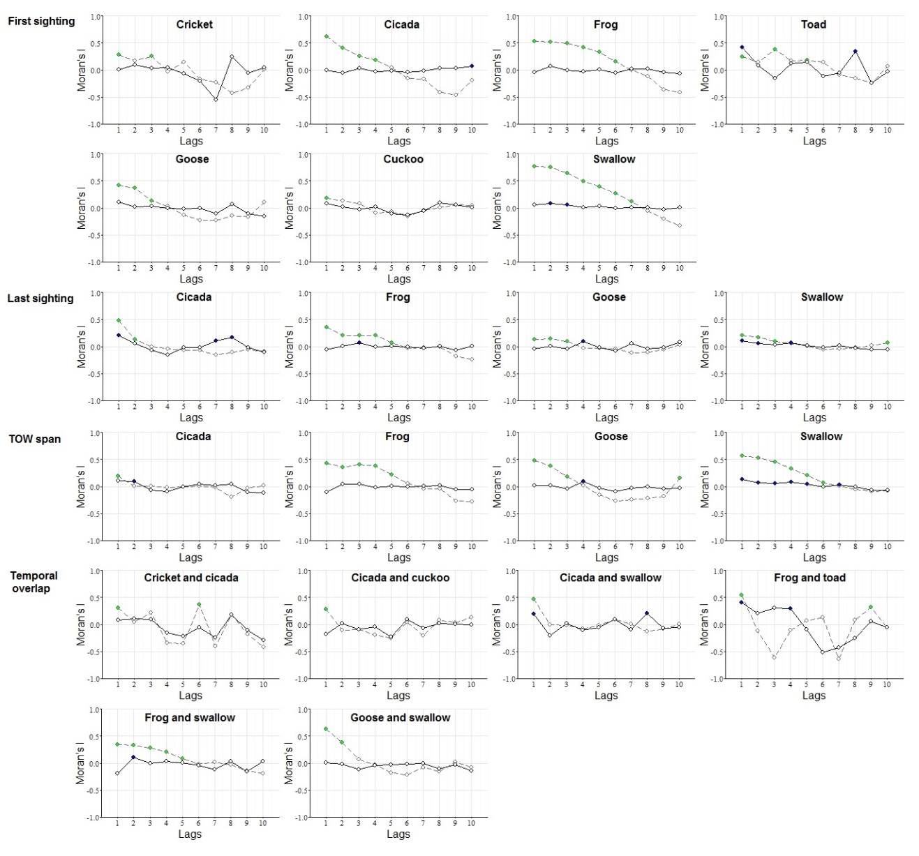

Fig. S1. Correlograms of time series for phenological trend over time for each taxon / taxon pair-phenological event combination that were identified to have spatial autocorrelation issues (i.e., cut-off distance > 0). Solid and dotted line respectively represent Moran’s I for the slope and intercept of LMM; solid dots represent Moran’s I values with P ≤ 0.05. Each lag is 200km.

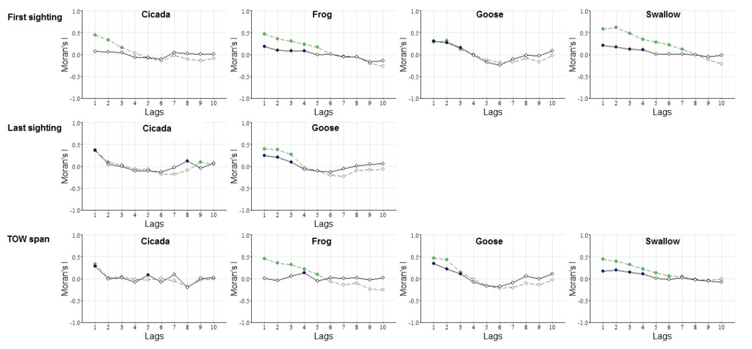

Fig. S2. Correlograms of time series for the relationship between phenological events and average minimum daily temperature for each taxon- / taxon pair-phenological event combination that were identified to have spatial autocorrelation issues (i.e., cut-off distance > 0). Solid and dotted line respectively represent Moran’s I for the slope and intercept of LMM; solid dots represent Moran’s I values with P ≤ 0.05. Each lag is 200km.

SI 4. Supplementary results
Table S4. Number of time series for each taxon that exhibited advanced (-) and delayed (+) phenological shift between 1981 and 2009.
Analysis | Operational taxa | Date of first sighting |  |  |  |  | Date of last sighting |  |  |  |  | Span of temporal occurrence window
 |  | Total† | - * | - • | + * | + • | Total† | - * | - • | + * | + • | Total† | - * | - • | + * | + •
Phenological trend over time | Cricket | 23 | 2 | 0 | 2 | 0 | 23 | 2 | 0 | 2 | 2 | 23 | 2 | 0 | 2 | 1
 | Cicada | 77 | 10 | 3 | 6 | 3 | 73 | 6 | 6 | 12 | 1 | 70 | 4 | 4 | 11 | 1
 | Bee | 10 | 2 | 0 | 1 | 0 | 1 | 0 | 0 | 1 | 0 | 1 | 0 | 0 | 1 | 0
 | Frog | 111 | 12 | 7 | 4 | 1 | 105 | 12 | 4 | 16 | 2 | 103 | 9 | 4 | 21 | 2
 | Toad | 36 | 4 | 3 | 2 | 0 | 31 | 3 | 0 | 3 | 1 | 32 | 3 | 1 | 9 | 0
 | Goose | 82 | 12 | 2 | 10 | 1 | 82 | 6 | 2 | 11 | 4 | 76 | 4 | 5 | 13 | 5
 | Wintering goose | 5 | 0 | 0 | 2 | 0 | 5 | 0 | 0 | 0 | 0 | 3 | 1 | 0 | 0 | 0
 | Hoopoe | 5 | 3 | 0 | 0 | 0 | 4 | 0 | 1 | 2 | 0 | 4 | 0 | 0 | 3 | 0
 | Cuckoo | 53 | 7 | 3 | 2 | 2 | 46 | 2 | 1 | 9 | 3 | 46 | 2 | 1 | 9 | 8
 | Swift | 4 | 1 | 0 | 0 | 0 | 4 | 0 | 0 | 2 | 0 | 4 | 0 | 0 | 2 | 0
 | Swallow | 250 | 53 | 17 | 20 | 5 | 233 | 19 | 6 | 48 | 8 | 239 | 21 | 5 | 55 | 7
Association between phenology and average minimum daily temperature | Cricket | 20 | 1 | 1 | 1 | 0 | 19 | 0 | 1 | 1 | 2 | 20 | 0 | 0 | 0 | 0
 | Cicada | 69 | 4 | 1 | 1 | 0 | 65 | 0 | 4 | 2 | 4 | 64 | 0 | 2 | 4 | 2
 | Bee | 5 | 1 | 0 | 0 | 0 | 0 | -- | -- | -- | -- | 0 | -- | -- | -- | --
 | Frog | 99 | 19 | 4 | 1 | 3 | 95 | 2 | 2 | 5 | 2 | 92 | 7 | 2 | 7 | 6
 | Toad | 30 | 7 | 3 | 0 | 0 | 31 | 0 | 1 | 2 | 0 | 31 | 2 | 2 | 5 | 3
 | Goose | 78 | 10 | 6 | 1 | 2 | 78 | 1 | 4 | 8 | 6 | 74 | 4 | 1 | 8 | 0
 | Wintering goose | 5 | 1 | 0 | 0 | 0 | 5 | 0 | 1 | 0 | 0 | 4 | 1 | 0 | 0 | 0
 | Hoopoe | 4 | 2 | 1 | 0 | 0 | 4 | 0 | 0 | 1 | 1 | 4 | 0 | 0 | 2 | 0
 | Cuckoo | 45 | 7 | 1 | 0 | 2 | 40 | 1 | 1 | 5 | 0 | 41 | 1 | 1 | 4 | 1
 | Swift | 4 | 0 | 1 | 0 | 0 | 4 | 0 | 0 | 0 | 0 | 4 | 0 | 0 | 1 | 0
 | Swallow | 256 | 38 | 17 | 9 | 3 | 252 | 16 | 5 | 28 | 12 | 252 | 11 | 6 | 31 | 18

Note: † - Total number refers to the number of time series used in analysis; time series that did not meet the linearity assumption were discarded. * refers to significance at the level of P ≤ 0.05; • refers to significance at the level of 0.05 < P ≤ 0.1.
Table S5. Number of time series that showed decrease (-) and increase (+) in the span of temporal overlap between taxon pairs between 1981 and 2009.
Taxon pair | Span of temporal overlap
 | Total† | - * | - • | + * | + •
Cricket – Cicada | 14 | 1 | 0 | 1 | 1
Cricket – Frog | 16 | 0 | 0 | 4 | 0
Cricket – Toad | 7 | 0 | 0 | 2 | 1
Cricket – Goose | 8 | 0 | 0 | 1 | 0
Cricket – Cuckoo | 6 | 0 | 0 | 2 | 1
Cricket – Swallow | 17 | 2 | 0 | 1 | 0
Cicada – Frog | 44 | 2 | 2 | 8 | 0
Cicada – Toad | 14 | 1 | 0 | 2 | 0
Cicada – Goose | 9 | 1 | 2 | 0 | 0
Cicada – Cuckoo | 15 | 1 | 0 | 3 | 1
Cicada – Swallow | 49 | 7 | 2 | 6 | 2
Frog – Toad | 15 | 0 | 1 | 5 | 1
Frog – Goose | 19 | 2 | 0 | 3 | 0
Frog – Cuckoo | 14 | 0 | 1 | 5 | 1
Frog – Swallow | 70 | 9 | 0 | 6 | 3
Toad – Goose | 5 | 0 | 1 | 0 | 0
Toad – Hoopoe | 1 | 0 | 0 | 1 | 0
Toad – Cuckoo | 8 | 0 | 1 | 2 | 1
Toad – Swift | 1 | 0 | 0 | 0 | 0
Toad – Swallow | 25 | 4 | 0 | 4 | 1
Goose – Hoopoe | 2 | 0 | 0 | 1 | 0
Goose – Cuckoo | 17 | 0 | 0 | 5 | 2
Goose – Swallow | 57 | 4 | 0 | 8 | 2
Hoopoe – Cuckoo | 2 | 0 | 0 | 1 | 0
Hoopoe – Swallow | 2 | 0 | 0 | 2 | 0
Cuckoo – Swallow | 37 | 3 | 0 | 7 | 3
Swift – Swallow | 3 | 0 | 0 | 1 | 0
Note: † - Total number refers to the number of time series used in analysis; time series that did not meet the linearity assumption were discarded. * refers to significance at the level of P ≤ 0.05; • refers to significance at the level of 0.05 < P ≤ 0.1.
Table S6. Classification of time series that showed change in inter-taxonomic temporal overlap according to the shift patterns of temporal occurrence windows of constituent taxa.
Category of time series | Number of time series that showed
 | Prolonged overlap | Shortened overlap
Temporal occurrence window advanced in both taxa | 12 | 0
Temporal occurrence window advanced in one taxon only | 46 | 4
No temporal occurrence window shift in either taxon | 37 | 26
Temporal occurrence window advanced in one taxon while delayed in the other | 3 | 2
Temporal occurrence window delayed in one taxon only | 3 | 14
Temporal occurrence window delayed in both taxa | 0 | 1

Table S7. Comparison of the direction of temporal overlap change between taxon pairs with the directions of change in the span of temporal occurrence windows of constituent taxa.
Direction of temporal overlap change | Number of overlap time series† | Number of time series whose direction of change was consistent with that of the span of temporal occurrence windows of:
 |  | Zero constituent taxon | One constituent taxon | Both constituent taxa
Prolonged | 101 | 13 | 60 | 24
Shortened | 47 | 5 | 36 | 1
Note: † - A few time series showed changes in inter-taxonomic temporal overlap, but their constituent taxa did not show changes in the span of temporal occurrence windows; these time series were therefore not classified into the subsequent categories in the table.

Table S8. Advanced (-) and delayed (+) trends or negative (-) and positive (+) relationships between phenology and average minimum daily temperature suggested by individual linear regressions based on different sub-data sets under progressively stricter trimming criteria.
Analysis | Trimming criterion | Phenological event† | Number of time series
 |  |  | Total‡ | - * | - • | + * | + •
Phenological trend over time | 5-8 | First sighting | 651 | 106 | 35 | 47 | 12
 |  | Last sighting | 602 | 50 | 20 | 106 | 21
 |  | TOW span | 598 | 45 | 20 | 126 | 24
 |  | TOW overlap | 477 | 37 | 10 | 81 | 20
 | 6-10 | First sighting | 590 | 99 | 33 | 44 | 10
 |  | Last sighting | 548 | 49 | 16 | 98 | 20
 |  | TOW span | 541 | 44 | 16 | 115 | 23
 |  | TOW overlap | 368 | 33 | 9 | 68 | 15
 | 11-11 | First sighting | 492 | 85 | 26 | 38 | 8
 |  | Last sighting | 446 | 38 | 13 | 87 | 18
 |  | TOW span | 439 | 37 | 13 | 98 | 17
 |  | TOW overlap | 243 | 24 | 7 | 51 | 11
 | 10-14 | First sighting | 328 | 69 | 18 | 24 | 5
 |  | Last sighting | 301 | 34 | 10 | 66 | 11
 |  | TOW span | 302 | 28 | 8 | 78 | 11
 |  | TOW overlap | 325 | 9 | 1 | 33 | 4
Association between phenology and average minimum daily temperature | 5-8 | First sighting | 610 | 89 | 35 | 13 | 10
 |  | Last sighting | 588 | 20 | 18 | 52 | 27
 |  | TOW span | 582 | 25 | 14 | 62 | 30
 | 6-10 | First sighting | 559 | 84 | 35 | 13 | 9
 |  | Last sighting | 538 | 17 | 17 | 47 | 26
 |  | TOW span | 528 | 24 | 13 | 60 | 27
 | 11-11 | First sighting | 474 | 77 | 31 | 12 | 9
 |  | Last sighting | 445 | 15 | 14 | 42 | 22
 |  | TOW span | 438 | 23 | 12 | 55 | 26
 | 10-14 | First sighting | 325 | 63 | 25 | 11 | 6
 |  | Last sighting | 316 | 14 | 9 | 36 | 18
 |  | TOW span | 311 | 19 | 9 | 53 | 20
Note: † - TOW refers to temporal occurrence window. ‡ - Total number refers to the number of time series used in analysis; time series that did not meet the linearity assumption were discarded. * refers to significance at the level of P ≤ 0.05; • refers to significance at the level of 0.05 < P ≤ 0.1.
Table S9. Overall patterns of taxon-level phenological response from linear mixed models based on different sub-data sets under progressively stricter trimming criteria.
Analysis | Phenological event† | Taxon | Results of phenological event
 |  |  | 5-8 | 6-10 | 11-11 | 10-14
Phenological trend over time | First sighting | Cricket | -* | -* | 0 | 0
 |  | Cicada | 0 | 0 | 0 | -*
 |  | Bee | 0 | 0 | 0 | -•
 |  | Frog | 0 | 0 | 0 | 0
 |  | Toad | -* | -* | 0 | +*
 |  | Goose | 0 | 0 | 0 | 0
 |  | Wintering goose | 0 | 0 | 0 | -*
 |  | Hoopoe | -• | -• | -• | -•
 |  | Cuckoo | -* | -* | 0 | -•
 |  | Swift | -• | -• | -• | -•
 |  | Swallow | 0 | 0 | 0 | 0
 | Last sighting | Cricket | 0 | 0 | +• | +•
 |  | Cicada | 0 | +* | 0 | 0
 |  | Bee | 0 | -- | NA | NA
 |  | Frog | 0 | 0 | 0 | 0
 |  | Toad | 0 | 0 | 0 | 0
 |  | Goose | 0 | +* | +* | +*
 |  | Wintering goose | 0 | 0 | 0 | 0
 |  | Hoopoe | 0 | 0 | 0 | 0
 |  | Cuckoo | +* | +* | +* | +*
 |  | Swift | +* | +* | +* | +*
 |  | Swallow | 0 | 0 | 0 | 0
 | TOW span | Cricket | +* | +* | +• | 0
 |  | Cicada | 0 | +* | 0 | +*
 |  | Bee | 0 | -- | -- | --
 |  | Frog | 0 | 0 | 0 | 0
 |  | Toad | 0 | +• | +• | -*
 |  | Goose | 0 | 0 | +• | 0
 |  | Wintering goose | 0 | 0 | 0 | 0
 |  | Hoopoe | 0 | 0 | 0 | 0
 |  | Cuckoo | +* | +* | +* | +*
 |  | Swift | +* | +* | +* | --
 |  | Swallow | 0 | 0 | 0 | 0
Association between phenology and average minimum daily temperature | First sighting | Cricket | +* | +* | +* | 0
 |  | Cicada | 0 | -• | 0 | -*
 |  | Bee | -• | -• | -• | -•
 |  | Frog | 0 | 0 | 0 | 0
 |  | Toad | 0 | 0 | 0 | 0
 |  | Goose | 0 | -• | -• | -*
 |  | Wintering goose | 0 | 0 | 0 | 0
 |  | Hoopoe | -* | -* | -* | -*
 |  | Cuckoo | +* | +* | +* | 0
 |  | Swift | 0 | 0 | 0 | 0
 |  | Swallow | 0 | 0 | 0 | 0
 | Last sighting | Cricket | 0 | 0 | 0 | 0
 |  | Cicada | -* | -* | -* | -*
 |  | Bee | -- | -- | -- | --
 |  | Frog | -* | 0 | 0 | 0
 |  | Toad | 0 | 0 | 0 | 0
 |  | Goose | 0 | 0 | +• | +*
 |  | Wintering goose | 0 | 0 | 0 | 0
 |  | Hoopoe | 0 | 0 | 0 | 0
 |  | Cuckoo | -• | -• | 0 | 0
 |  | Swift | 0 | 0 | 0 | 0
 |  | Swallow | 0 | +• | 0 | 0
 | TOW span | Cricket | -* | -* | -* | 0
 |  | Cicada | 0 | 0 | 0 | 0
 |  | Bee | -- | -- | -- | --
 |  | Frog | 0 | 0 | 0 | 0
 |  | Toad | 0 | 0 | 0 | 0
 |  | Goose | 0 | +• | +• | +•
 |  | Wintering goose | 0 | 0 | 0 | 0
 |  | Hoopoe | +* | +* | +* | +*
 |  | Cuckoo | 0 | 0 | 0 | 0
 |  | Swift | 0 | 0 | 0 | --
 |  | Swallow | 0 | 0 | 0 | 0
Note: † - TOW refers to temporal occurrence window. * refers to significance at the level of P ≤ 0.05; • refers to significance at the level of 0.05 < P ≤ 0.1.

Table S10. Overall patterns of temporal overlap change between taxon pairs from linear mixed models based on different sub-data sets under progressively stricter trimming criteria.
Taxon pair | Results of overlap change
 | 5-8 | 6-10 | 11-11 | 10-14
Cricket – Cicada | +* | +• | 0 | --
Cricket – Frog | +* | +* | +* | 0
Cricket – Toad | +* | +* | +* | --
Cricket – Goose | +* | 0 | -- | --
Cricket – Cuckoo | 0 | +• | 0 | --
Cricket – Swallow | 0 | 0 | 0 | 0
Cicada – Frog | +* | +• | 0 | +*
Cicada – Toad | 0 | 0 | 0 | 0
Cicada – Goose | 0 | 0 | 0 | 0
Cicada – Cuckoo | 0 | 0 | 0 | --
Cicada – Swallow | -• | 0 | 0 | +*
Frog – Toad | +* | +* | 0 | 0
Frog – Goose | 0 | 0 | 0 | 0
Frog – Cuckoo | +* | +* | 0 | +*
Frog – Swallow | 0 | 0 | 0 | 0
Toad – Goose | 0 | 0 | 0 | 0
Toad – Hoopoe | +* | +* | +* | +*
Toad – Cuckoo | 0 | 0 | 0 | 0
Toad – Swift | 0 | 0 | -- | --
Toad – Swallow | 0 | 0 | 0 | 0
Goose – Hoopoe | +* | +* | +* | +*
Goose – Cuckoo | +* | +* | +* | +*
Goose – Swallow | +• | +* | +* | 0
Hoopoe – Cuckoo | +* | +* | +* | +*
Hoopoe – Swallow | +• | +• | +• | +•
Cuckoo – Swallow | +* | +* | +* | +*
Swift – Swallow | 0 | 0 | 0 | --
Note: * refers to significance at the level of P ≤ 0.05; • refers to significance at the level of 0.05 < P ≤ 0.1.

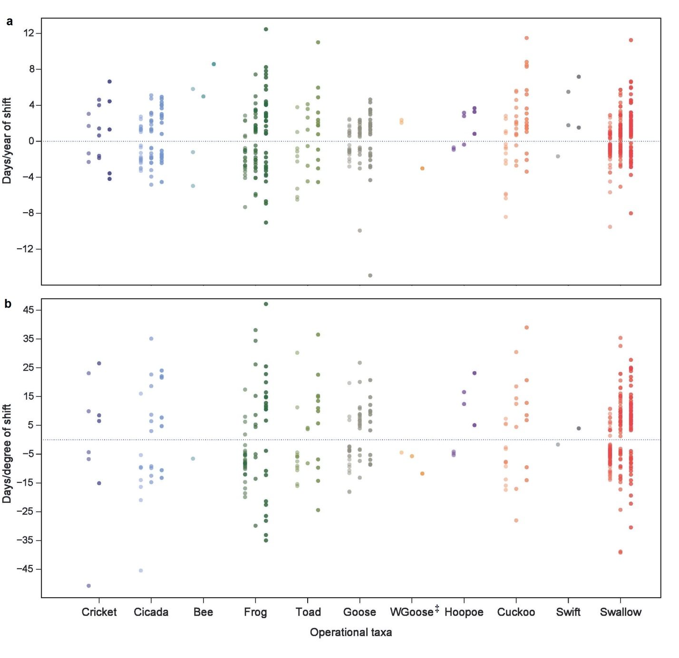

Fig. S3. Trend of phenological shift by taxon at each site as measured by number of days shifted per year. Each dot represents a time series; the three shades for each taxon represent the three phenological events: first sighting, last sighting, and span of temporal occurrence window. Figure only displays time series that exhibited shifts (P ≤ 0.1). ‡ - “WGoose” refers to wintering goose.

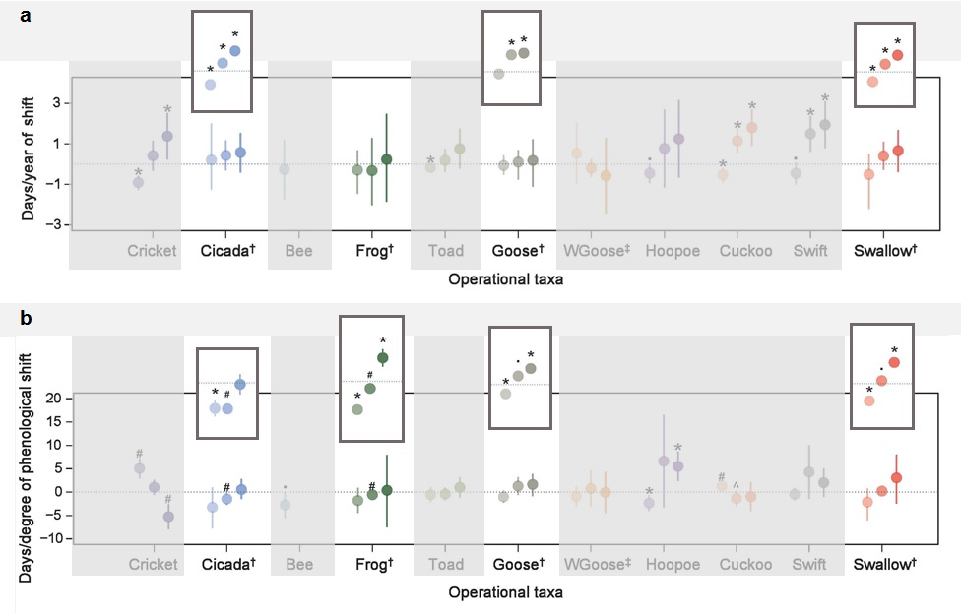

Fig. S4. Lack of statistically significant patterns of phenological shift over time (a) and relationship between phenology and average minimum daily temperature (b) for four taxa that had extremely small sample sizes after subsampling (i.e., those marked with †) was likely due to low statistical powers. Analysis results for these taxa using the full data set (shown in insets; thus disregarding the potential problem introduced by spatial autocorrelation) were generally significant and consistent with signatures of climate change. (a): Taxon-level phenological shift as measured by days shifted per year. The three points (left to right; different color shades) for each taxon respectively represent first sighting, last sighting, and span of temporal occurrence windows; error bars indicate 95% confidence interval. (b): Association between phenological shift and climate change as measured by days shifted per degree increase in average minimum daily temperature; error bars indicate 95% confidence interval. Significant patterns consistent with expected impacts of climate change are indicated with * (P ≤ 0.05) and • (0.05 < P ≤ 0.1); significant opposite patterns are indicated with # (P ≤ 0.05) and ^ (0.05 < P ≤ 0.1). ‡ - “WGoose” refers to wintering goose.

